Safety Case
  - ISO26262 - Recommended Practice Template

Project: | ISO 26262: Recommended Practice – SMARTcode
Company: | n.a.
Document Status: | Verified
Maturity Level: | <50% compliant
Author: |  | Company: |  | Role: |  | Email:
[author] |  | [company name] |  | [role] |  | [@address]
Stakeholder: |  | Company: |  | Role: |  | Email:
[stakeholder_ 1] |  | [company name] |  | [role] |  | [@address]
[stakeholder_ 2] |  | [company name] |  | [role] |  | [@address]
[stakeholder_ 3] |  | [company name] |  | [role] |  | [@address]
[stakeholder_ 4] |  | [company name] |  | [role] |  | [@address]
[stakeholder_ x] |  | [company name] |  | [role] |  | [@address]

Change History
Revision | Date | Author | Chapter(s) | Reason | Change
1 | 01-01-2016 | J. Johnsson | 1 | Content out of date | Removed completed tasks

Table of Contents
1 To do list 3
2 RASI(C) chart 3
3 Conventions 4
3.1 Document status 4
3.2 Maturity level assignment 5
4 Abbreviated terms 6
5 Purpose and scope 6
6 Related documents 6
6.1 Input documents 6
6.2 Work products 6
6.3 Other related documents 7
7 ISO26262 compliance 7
7.1 Maturity level indication rationale 7
7.2 Elements and aspects of this document which are not compliant to ISO26262 7
8 Overview of created functional safety work products 8
8.1 Work product x 8
8.2 Work product x+1 8
Appendix A – Review form for Safety Case Template (Template only!!!) 9

To do list

RASI(C) chart
Fill in the responsibilities with regards to this document in the RASI(C) chart below.
 | Name | Tasks/Activities | Company | Email address
Responsible | James Smith |  | CompanyX | jsmith@companyx.com
Accountable
Supportive
Informed
Consulted (optional)

Name | Role | Role description
James Smith | FSM | Functional Safety Manager, responsible for the conformance of [company / department] to ISO26262.
[name] | [role] | [description]
Responsibility | Description
Responsible | The person who is ultimately responsible for the delivery of the work product. This person has to ensure the correctness, completeness, retention and availability of this document.
Accountable | The person who has ultimate accountability and approval authority. This person is legally responsible for the correct implementation according to ISO26262.
Supportive | The team or person(s) supporting carrying out the “real” work. They are committed to the completion of the work product.
Informed | Person(s) who must stay informed regarding results or actions taken but are not involved in final decision-making.
Consulted | (Optional) Those who can provide valuable input into the development of work products and are capable of determining the quality and correctness of the work product.

Conventions

Document status
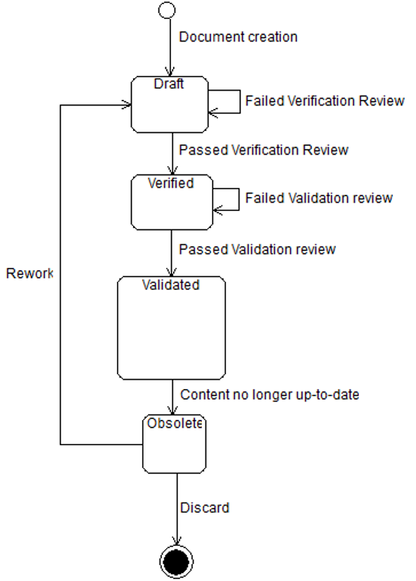
Document life cycle
Draft | When a new document is created the status “Draft” will be assigned. Only after a positive verification review the document can be promoted to “Verified” by performing a verification review. Also Obsolete documents can be assigned the status “Draft” after changes have been made to update.  Please refer to ISO26262-2 Table D.1 – Overview of verification reviews.
Verified | Status after a successful verification review according to ISO26262-2 has been performed on a document with status “Draft”.
Validated | Status after a successful validation review according to ISO26262-2 has been performed on a document with status “Verified”.
Obsolete | The status of the document should be changed to “Obsolete” when its contents no longer match the current state of the Item, System or organization it concerns, regardless of the former document state.

Maturity level assignment
At every validation review an estimate is made regarding the maturity level of this document. The estimate is based on the amount of ISO26262 requirements this document satisfies in relation to how many still have to be satisfied.
Only the person(s) responsible for the validation review may determine the maturity level of the Safety Case documents.

The maturity level will be assigned based on a scale of 0 – 4:
- Not compliant
- <50% compliant, roughly half of the aspects mentioned in ISO26262 are covered
- <75% compliant, roughly ¾ of the aspects mentioned in ISO26262 are covered
- <90% compliant, most of the aspects mentioned in ISO26262 are covered
- >90% compliant, so far to judge every aspect of the ISO26262 is covered

Abbreviated terms
List all abbreviations here which are used in this document and are not covered by ISO26262-1 Clause 2

Purpose and scope
The purpose of this document is to provide a status overview of the functional safety related documents created during the project development, which is a prerequisite for a safety-oriented development. This document progressively compiles the work products that are generated during the safety lifecycle. The result of the corresponding reviews and the measures determined in the review reports are introduced and the status of the measures are described.
- In addition, deviations or requirements, not (yet) implemented until establishing of the specific document are listed together with a short description (reason) and an assessment of the resulting risks (mandatory!)
- The project safety plan is stated as the basic document for the focussed project documentation (tailoring of the safety case documents)
The safety case is mandatory for all ASIL levels.
Degree of independency for the confirmation measures (ISO62626-2, Table 1):
 | ASIL A | ASIL B | ASIL C | ASIL D
The confirmation review of the completeness of the safety case | I0 | I1 | I2 | I3
Independence with regards to the authors of the safety case | I0 | I1 | I2 | I3

Related documents

The Safety Case contains the status information of each work product which is subject to ISO26262 concerning the Item which is described in the Item Definition.

ISO26262 compliance

Maturity level indication rationale
Which requirements of ISO26262-2 clause 6.4.6 are covered and which are not?
What is the current requirements-coverage of this document according to ISO26262. Please also describe how this is defined/calculated.

Elements and aspects of this document which are not compliant to ISO26262
Which elements are missing in this document or which elements are not conform ISO26262? Refer to ISO26262 requirements.
Provide measures to be taken to enhance compliancy to ISO26262.
(Example: )
Requirement | Issue | Measure | Trigger
9.4.4 The results of the validation shall be evaluated. | Evaluation is not yet mentioned in this document. | Describe evaluation measures.  Define the evaluation in the Safety Plan. | Put on roadmap

Overview of created functional safety work products

Work product x
Current valid version and date | V1.2
Created by | Forename, surname, role
Memory location | Document path or link to document
Last reviewed version | V1.1
Memory location of the latest review report | Document path of link to document
Names of reviewer having the required independency | Forename, Surname, role
Review result | □ Accepted | □ Conditionally Accepted |  |  | □ Rejected
Deviations identified / action items defined in lastly performed review | Fill in
Status of above mentioned deviations / action items | Fill in
Differences / changes of current version against previous or planned version (with arguments!)  Rating of the work product by the project | Fill in
Rating of the work product by the project | □ O.K. |  | □ Conditionally O.K. | □ Not yet finished
Remarks | n.a.

Attention: the work products listed below shall be completed respectively tailored to cover the work products planned in the Project Safety Plan and the belonging plans.

Work product x+1
(place review table here)

Appendix A – Review form for Safety Case Template (Template only!!!)

Change History
Revision | Date | Author | Chapter(s) | Reason | Description
0.01 | 04-07-2016 | R. vd Boom | All | Increase usability of these documents | Processing general feedback to all template documents

Review Log
Revision | Date | Reviewer | Chapter(s) | Result | Comments
1

Notes to editor

